Hotel International Reservation
한국소음진동공학회

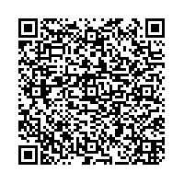
2022. 05. 25 ~ 05. 28

Booking Detail
- Name
- Phone
- Check In
- Check Out
- No. of Rooms
- Room Type | BUSINESS DOUBLE /  BUSINESS TWIN
- Breakfast | Yes / No
- Payment : Creditcard Number |  | Valid (MM/YY: / )

Convenience Facilities
- FREE Sauna & Gym | - Business Center
- FREE Wi-Fi Internet | - Music Live Bar
- FREE Parking Area | - Coffee shop
- 24hr Front Desk

Cancelation Policy is subject to exceptions
- 체크인 기준 5일 전 : 위약금 없음
- 체크인 기준 3일 전 : 요금의 30% 청구
- 체크인 기준 1일 전 : 요금의 50% 청구
- 체크인 당일 : 요금의 100% 청구

Please contact us at any time if you have any inquires.
We look forward to welcoming Hotel International.

Sincerely Yours,
Kang Rina / Assistant-Manager

